**Name: Nguyễn Thị Hà Giang**

**MSV: 22IT072**

**BÀI TẬP CHƯƠNG 6**

* **Employee**

Form1.cs

using System.Text;

namespace Employee

{

public partial class Form1 : Form

{

public Form1()

{

InitializeComponent();

}

private void button1_Click(object sender, EventArgs e)

{

string EmployeeID = txtEmployeeID.Text;

string EmployeeName = txtEmployeeName.Text;

string Phone = mtxtPhone.Text;

string Gender = (rdFemale.Checked ? "Female" : "Make");

string Degree = cboDegree.Text;

StringBuilder builder = new StringBuilder();

builder.Append($"EmployeeID:{EmployeeID}\n");

builder.Append($"EmployeeName:{EmployeeName}\n");

builder.Append($"Phone:{Phone}\n");

builder.Append($"Gender:{Gender}\n");

builder.Append($"Degree:{Degree}\n");

MessageBox.Show(builder.ToString(), "Employee Details");

}

private void button2_Click(object sender, EventArgs e)

{

this.Close();

}

}

}

Result:

* **DataGridView**

Form1.cs

using System.Data;

namespace frmDataGridView

{

public partial class Form1 : Form

{

public Form1()

{

InitializeComponent();

}

private void btnDataTable_Click(object sender, EventArgs e)

{

DataTable products = new DataTable();

products.Columns.Add("ProductID", typeof(int));

products.Columns.Add("ProductName", typeof(string));

products.Columns.Add("UnitPrice", typeof(decimal));

products.Rows.Add(1, "Mouse", 10.5);

products.Rows.Add(2, "Keyboard", 20.8);

dgvProducts.DataSource = products;

}

private void btnList_Click_Click(object sender, EventArgs e)

{

List<dynamic> products = new List<dynamic>()

{

new { ProductID = 3, ProductName = "Speaker", UnitPrice = 14.9 },

new { ProductID = 4, ProductName = "Monitor", UnitPrice = 50.5 }

};

dgvProducts.DataSource = products;

}

}

}

Result:

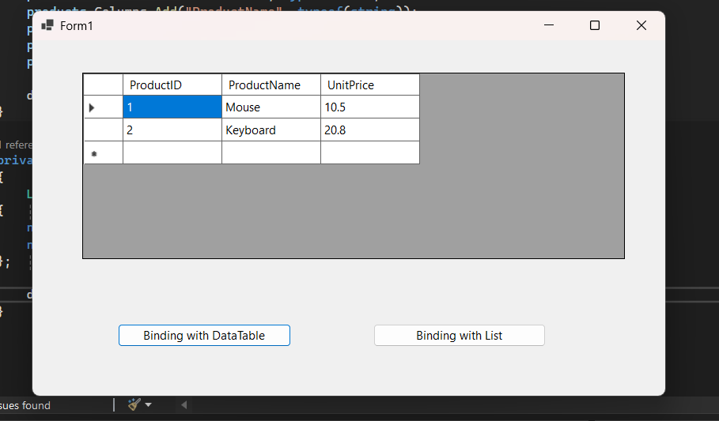

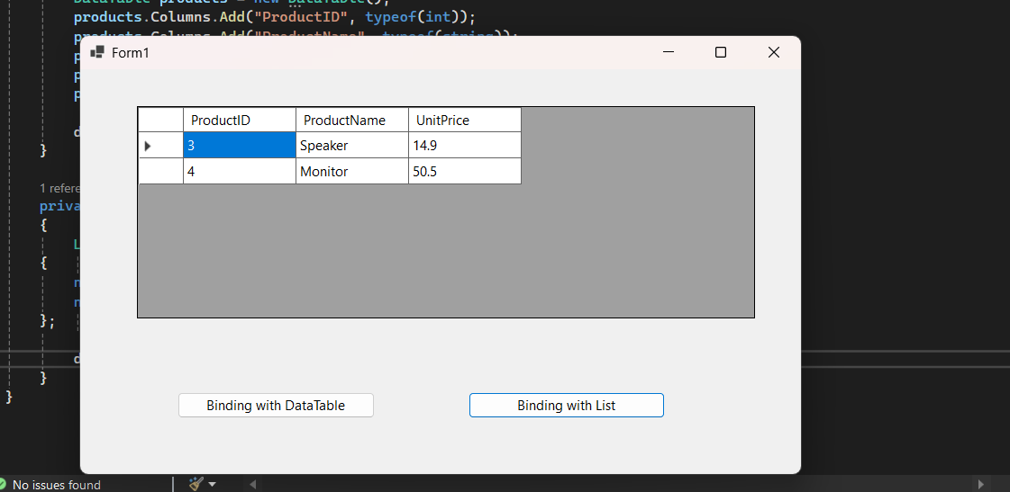

* **ProgressBar**

Form1.cs

namespace CopyWithProgress

{

public partial class Form1 : Form

{

public Form1()

{

InitializeComponent();

this.Load += Form1_Load;

}

private void Form1_Load(object sender, EventArgs e)

{

string[] filenames = { "File1.txt", "File2.txt", "File3.txt", "File4.txt", "File5.txt" };

CopyWithProgress(filenames);

}

private void CopyWithProgress(string[] filenames)

{

pBMain.Minimum = 1;

pBMain.Maximum = filenames.Length;

pBMain.Value = 1;

pBMain.Step = 1;

for (int x = 1; x <= filenames.Length; x++)

{

if (CopyFile(filenames[x - 1]) == true)

{

pBMain.PerformStep();

}

}

}

private bool CopyFile(string fileName)

{

return true;

}

}

}

Result:

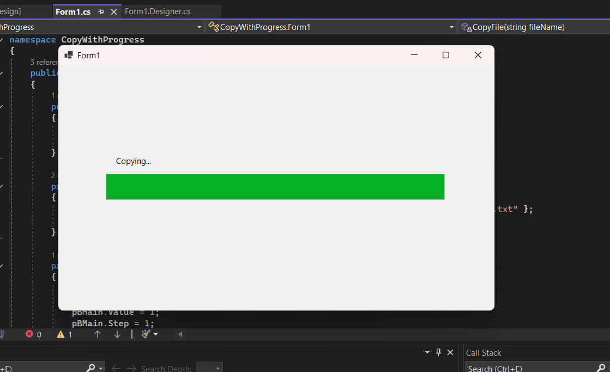

* **DateTimerPicker**

Form1.cs

namespace DateTimerPicker

{

public partial class Form1 : Form

{

public Form1()

{

InitializeComponent();

}

private void Form1_Load(object sender, EventArgs e)

{

dateTimePicker1.Format = DateTimePickerFormat.Custom;

dateTimePicker1.CustomFormat = "dddd, dd/MM/yyyy";

}

}

}

Result

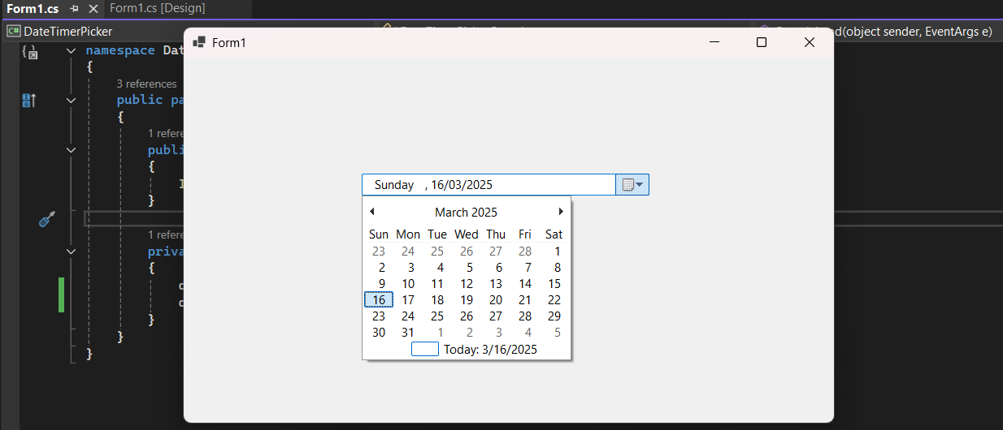

* Timer

Form1.cs

namespace TimeApp

{

public partial class Form1 : Form

{

public Form1()

{

InitializeComponent();

}

private void timer1_Tick(object sender, EventArgs e)

{

lbCurrentTime.Text = DateTime.Now.ToLongTimeString();

}

private void Form1_Load(object sender, EventArgs e)

{

timer1.Interval = 1000; // Cập nhật mỗi giây

timer1.Tick += timer1_Tick;

timer1.Start();

}

}

}

Result:

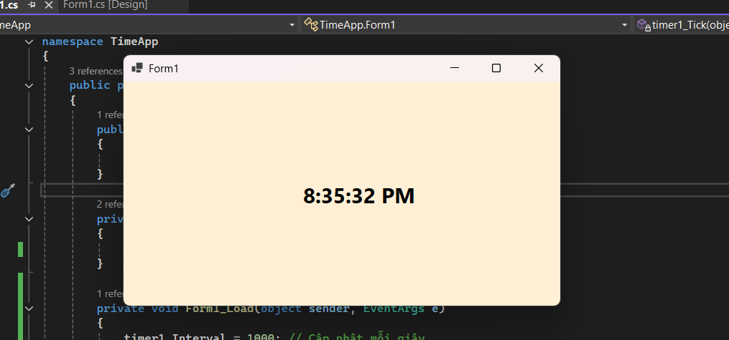

* MenuStrips

frmMain.cs

using System;

using System.Collections.Generic;

using System.ComponentModel;

using System.Data;

using System.Drawing;

using System.Linq;

using System.Text;

using System.Threading.Tasks;

using System.Windows.Forms;

namespace MenuStrips

{

public partial class frmMain : Form

{

public frmMain()

{

InitializeComponent();

}

private void frmMain_Load(object sender, EventArgs e)

{

CreateMyMainMenu();

}

private void CreateMyMainMenu()

{

MenuStrip mainMenu = new MenuStrip();

this.Controls.Add(mainMenu);

this.MainMenuStrip = mainMenu;

ToolStripMenuItem menuFile = new ToolStripMenuItem("&File");

ToolStripMenuItem mnuNew = new ToolStripMenuItem("&New");

ToolStripMenuItem mnuOpen = new ToolStripMenuItem("&Open");

ToolStripSeparator separator = new ToolStripSeparator();

ToolStripMenuItem mnuExit = new ToolStripMenuItem("&Exit");

ToolStripMenuItem mnuAbout = new ToolStripMenuItem("&About");

ToolStripMenuItem mnuViewAbout = new ToolStripMenuItem("&View About");

// mainMenu

mainMenu.Items.AddRange(new ToolStripItem[] { menuFile, mnuAbout });

// menuFile

menuFile.DropDownItems.AddRange(new ToolStripItem[] { mnuNew, mnuOpen, separator, mnuExit });

// mnuAbout

mnuAbout.DropDownItems.AddRange(new ToolStripItem[] { mnuViewAbout });

// mnuOpen

mnuOpen.ShortcutKeys = (Keys)((Keys.Control | Keys.O));

// mnuExit

mnuExit.ShortcutKeys = (Keys)((Keys.Alt | Keys.X));

mnuExit.Click += new EventHandler(mnuExit_Click);

// mnuViewAbout

mnuViewAbout.ShortcutKeys = Keys.F1;

mnuViewAbout.Click += new EventHandler(mnuViewDetail_Click);

}

private void mnuExit_Click(object sender, EventArgs e)

{

MessageBox.Show("Welcome to Windows Forms Application with .NET", "About");

}

private void mnuViewDetail_Click(object sender, EventArgs e)

{

Application.Exit();

}

private void newToolStripMenuItem_Click(object sender, EventArgs e)

{

}

}

}

Result:

